The Leasehold and the Freehold of 186 Kirkdale

Before Kirkdale School
The plot of land and the building at 186 Kirkdale are shown on maps that date back to 1895.
The plot and the footprint of the building remained largely unchanged between 1895 and 1965.
The property, together with many others, was owned by the Forester Estate Development Company. The Forrester family had lands in Kent and Hampshire as well as in Lewisham. A substantial amount of land owned by the Forester family was obtained between the years 1810 and 1819 by Inclosure (Enclosure).
On the 23rd of July 1947 the Forester Estate Development Company leased 186 Kirkdale to Joseph Alexander Dingwall “A London medial Practitioner” for a period of twenty six years.
On the 29th of November 1963 Dr HJA Dingwall appointed the Midland Bank as executor of his will.
On the 25th of May 1964 Dr HJA Dingwall died.
On the 6th of October 1964 Probate was granted to the Midland Bank.
On the 1st of December 1964 The Midland Bank surrendered the lease to the Forester Estate Development Trust.
The incoming of Kirkdale School
At this stage the paper trail is interrupted, however I believe that the lease of the property was probably granted to John Powlesland for five years from the 25th of March 1965, though it is possible that this was done at any stage from the 1st of December 1964. It may be that an informal arrangement was made that enabled the Powlesland family and pets to move in to 186 from their former home in Gillingham Kent in advance of the signing of the lease.
The school opened in 1965.
Cont....
Renewal of the lease
On the 17th of February 1970 The Trustees of the Forester Estate Development Company leased 186 Kirkdale to John James Alexander Powlesland “Schoolmaster”. The lease ran from 25th of March 1970 for a term of three years at yearly rent of five hundred pounds. John Powlesland’s signature was witnessed by David Lyle “Architect”.
At some point after this 1970 lease was signed the property ownership transferred to Quadrant Housing Association.
Quadrant Housing Association’s mission was to end homelessness. The purpose of the purchase of 186 Kirkdale was to obtain land for redevelopment. The end point envisaged was the demolition of the property and the building of new dwellings on the site.
The ever present threat of non renewal of the lease was a constant source of worry and frustration to John Powlesland and the years that followed the signing of the 1970 lease were dotted with skirmishes between members of Kirkdale School Ltd and Quadrant Housing Association. David Lyle managed to get a tree preservation order placed on the copper beech tree to the left of the front lawn as seen from the road. This saved the tree when in the 1970’s the developers who also owned the property to the left began to cut into the plot of land at 186 Kirkdale.
I believe that once the lease ran out in 1973 an agreement was reached between John Powlesland and Quadrant Housing Association that allowed the school to remain at the property on a short term renewable basis which could be terminated once the developers were ready to redevelop the plot. John Powlesland, the original lessee, died in 1977.
The school remained in residence until the 1980s.
The property changed hands a number of times moving from Quadrant Housing Association, latterly London and Quadrant Housing Trust (L&Q) to the Carr-Gomm Society Limited and it is now owned by Sanctuary Housing Association, an Industrial Provident Society.
Cont...

A legacy to be proud of
The occupancy of 186 Kirkdale by Kirkdale School ran on long enough to allow for a change in attitude towards old buildings to come to the fore with the accent on preservation rather than demolition.
All of the work and energy put in to re negotiating terms by which the School could remain on the site; on preserving the beech tree and to having the development of the plot deferred has contributed to the preservation of the building and to the maintaining a large open space to the front.
The property which is divided into circa 8 flats, now sits within the Jew’s Walk Conservation Area, one of 27 such conservation areas within the London Borough of Lewisham.
A sketch of the plot and house at 186 Kirkdale before and after development is given below.
Cont...

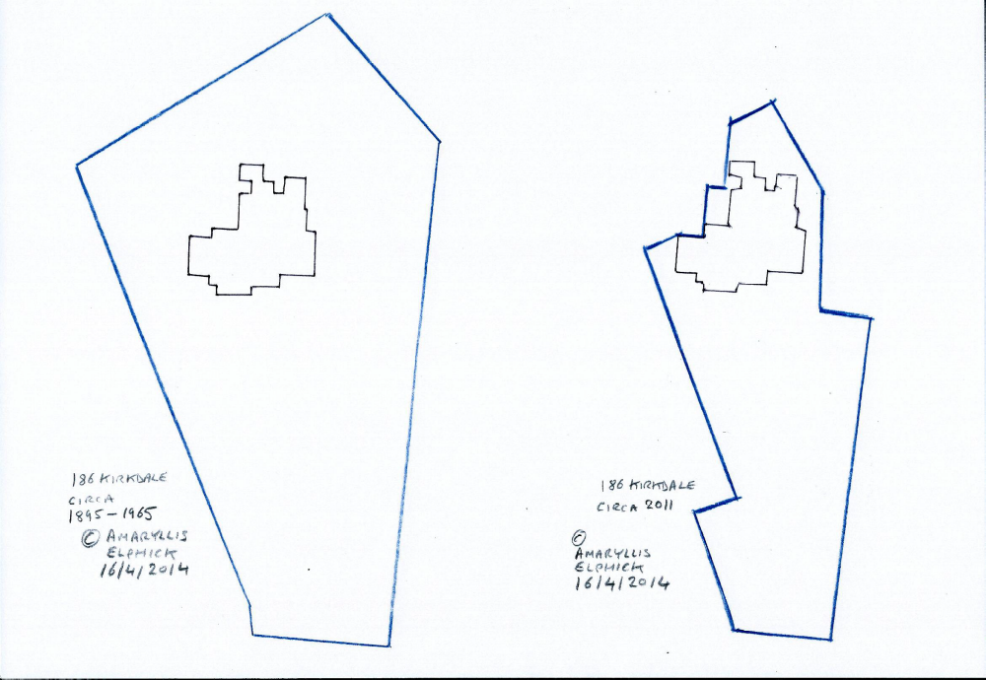
186 Kirkdale Before and after the developers got to work

http://www.nationalarchives.gov.uk/a2a/records.aspx?cat=089-a934&cid=-1#-1
http://www.lqgroup.org.uk/services-for-residents/about-landq/history-of-landq/
http://www.lewisham.gov.uk/myservices/planning/conservation/conservation-areas/Pages/maps-of-conservation-areas.aspx

